DFD

for

Soccer Live Platform

Version: 1.0

Prepared by: Usman Awan | 22F-3378

Organization: FAST NUCES CFD

Date: 9 Dec, 2024

Contents

DFD Level 0 3

Diagram 3

DFD: Level 1 4

Diagram 4

DFD: Level 2 5

Diagram 5

# DFD Level 0

The **Level 0 DFD** provides a high-level overview of the entire Soccer Live system, illustrating the interactions between external entities, the system itself, and supporting resources like external APIs and the database. At this level, the **User** and **Admin** are the two primary external entities interacting with the system. The **User** accesses the system to view live matches, manage their profile, and receive notifications, while the **Admin** manages content and user accounts.

The system, represented as a single process, handles various functionalities such as user authentication, profile management, live match streaming, and notification generation. It communicates with an **External API** to fetch real-time match data and updates, while the **Database** stores user-related information, preferences, and content data like match schedules, user profiles, and streaming details. The flow of data between these entities ensures that users can interact with the system to access live soccer content and receive notifications based on their preferences, while admins manage content and user accounts effectively.

This diagram serves as a foundational overview, capturing the core interactions without delving into detailed processes.

## Diagram

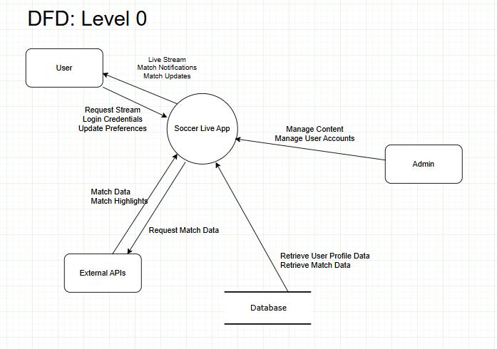

# DFD: Level 1

In the **Level 1 DFD**, the system is broken down into five key sub-processes: **Profile Management**, **Match Streaming**, **Notification Generation**, **Content Selection**, and **Authentication**.

* **Profile Management** handles user-related actions, such as retrieving and updating their profile details, preferences, and settings. The user can update their profile, including language preferences, notification settings, and other personal data, which are then stored in the system.
* **Match Streaming** is responsible for streaming live matches and sending updates to users. It fetches real-time match data from external APIs and streams the match content based on the user's internet bandwidth. This sub-process ensures a smooth and continuous viewing experience.
* **Notification Generation** manages user notifications, such as sending alerts for match updates, goals, halftime, and other important events. It generates real-time notifications based on the user's preferences and sends them through various channels.
* **Content Selection** allows the admin to manage and update the content available to users, such as match schedules and highlights. It ensures that the system delivers up-to-date and relevant content based on the user's location, preferences, and real-time updates from APIs.
* **Authentication** handles the process of user login and registration, validating the credentials entered by the user. It checks the user's information against the database and authenticates the user before granting access to the system, ensuring secure user management.

## Diagram

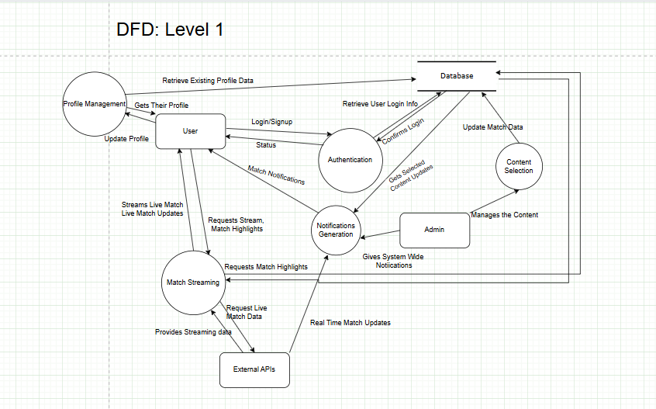

# DFD: Level 2

The Level 2 DFD for **Match Streaming** focuses on three main sub-processes: **Stream Optimization**, **Real-Time Data Fetching**, and **Cached Data Handling**. **Stream Optimization** adjusts the video quality based on the user's internet speed, ensuring smooth playback with minimal buffering. If the network is slow, it reduces the stream's resolution; if the network is fast, it increases the resolution for better video quality. **Real-Time Data Fetching** continuously pulls live match data, such as scores and event updates, from external APIs to keep the stream synchronized with the match. If live data is unavailable or delayed, **Cached Data Handling** ensures the user still receives previously stored match data or highlights until the live feed is restored. These processes work together to deliver an optimal and uninterrupted viewing experience.

## Diagram

